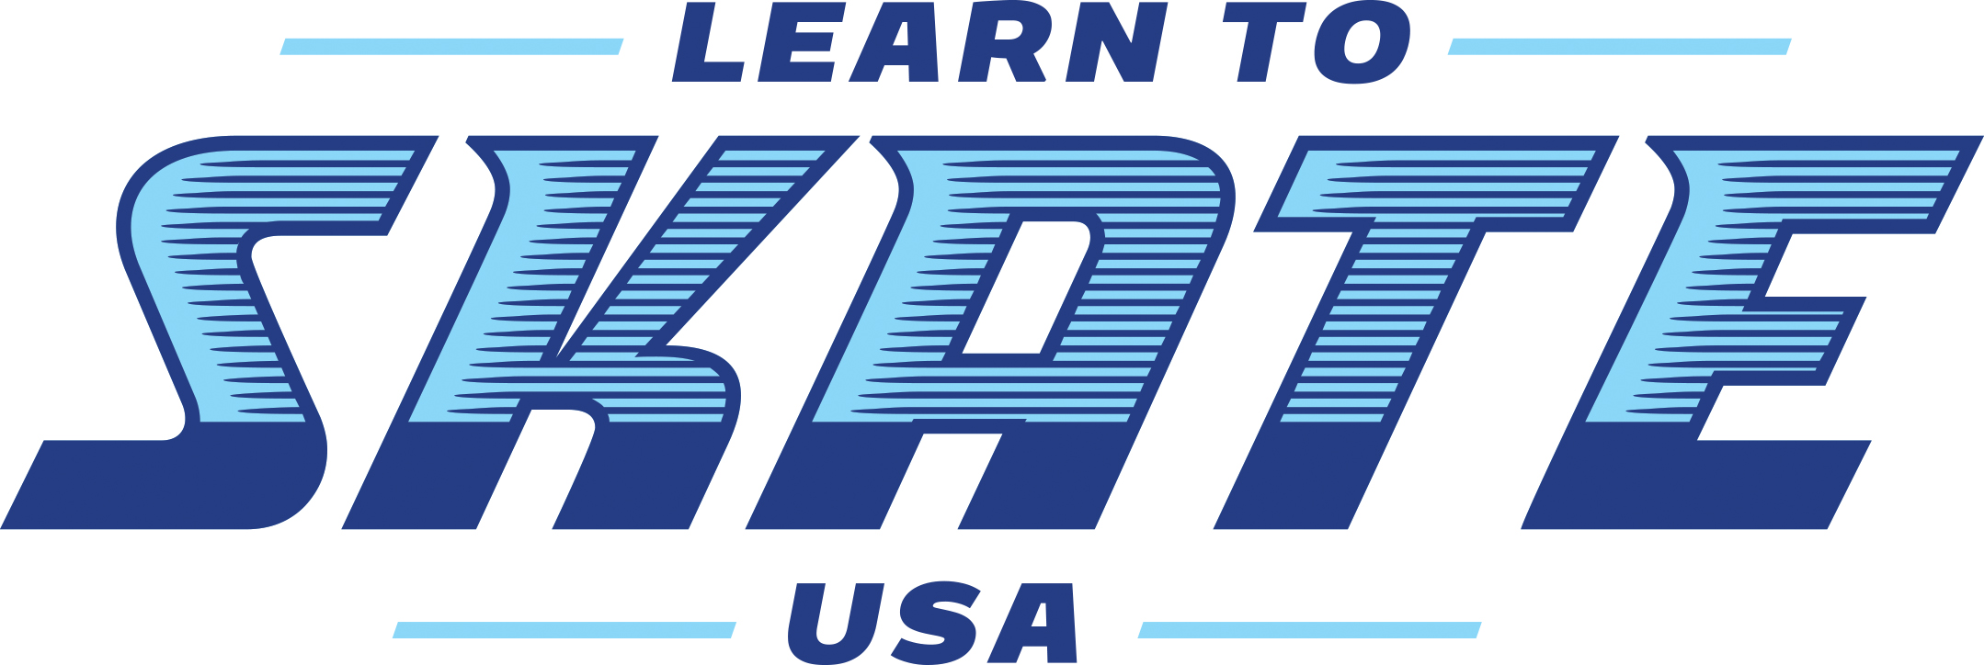

Quad Cities Basic Skills Competition
June 8-10, 2018

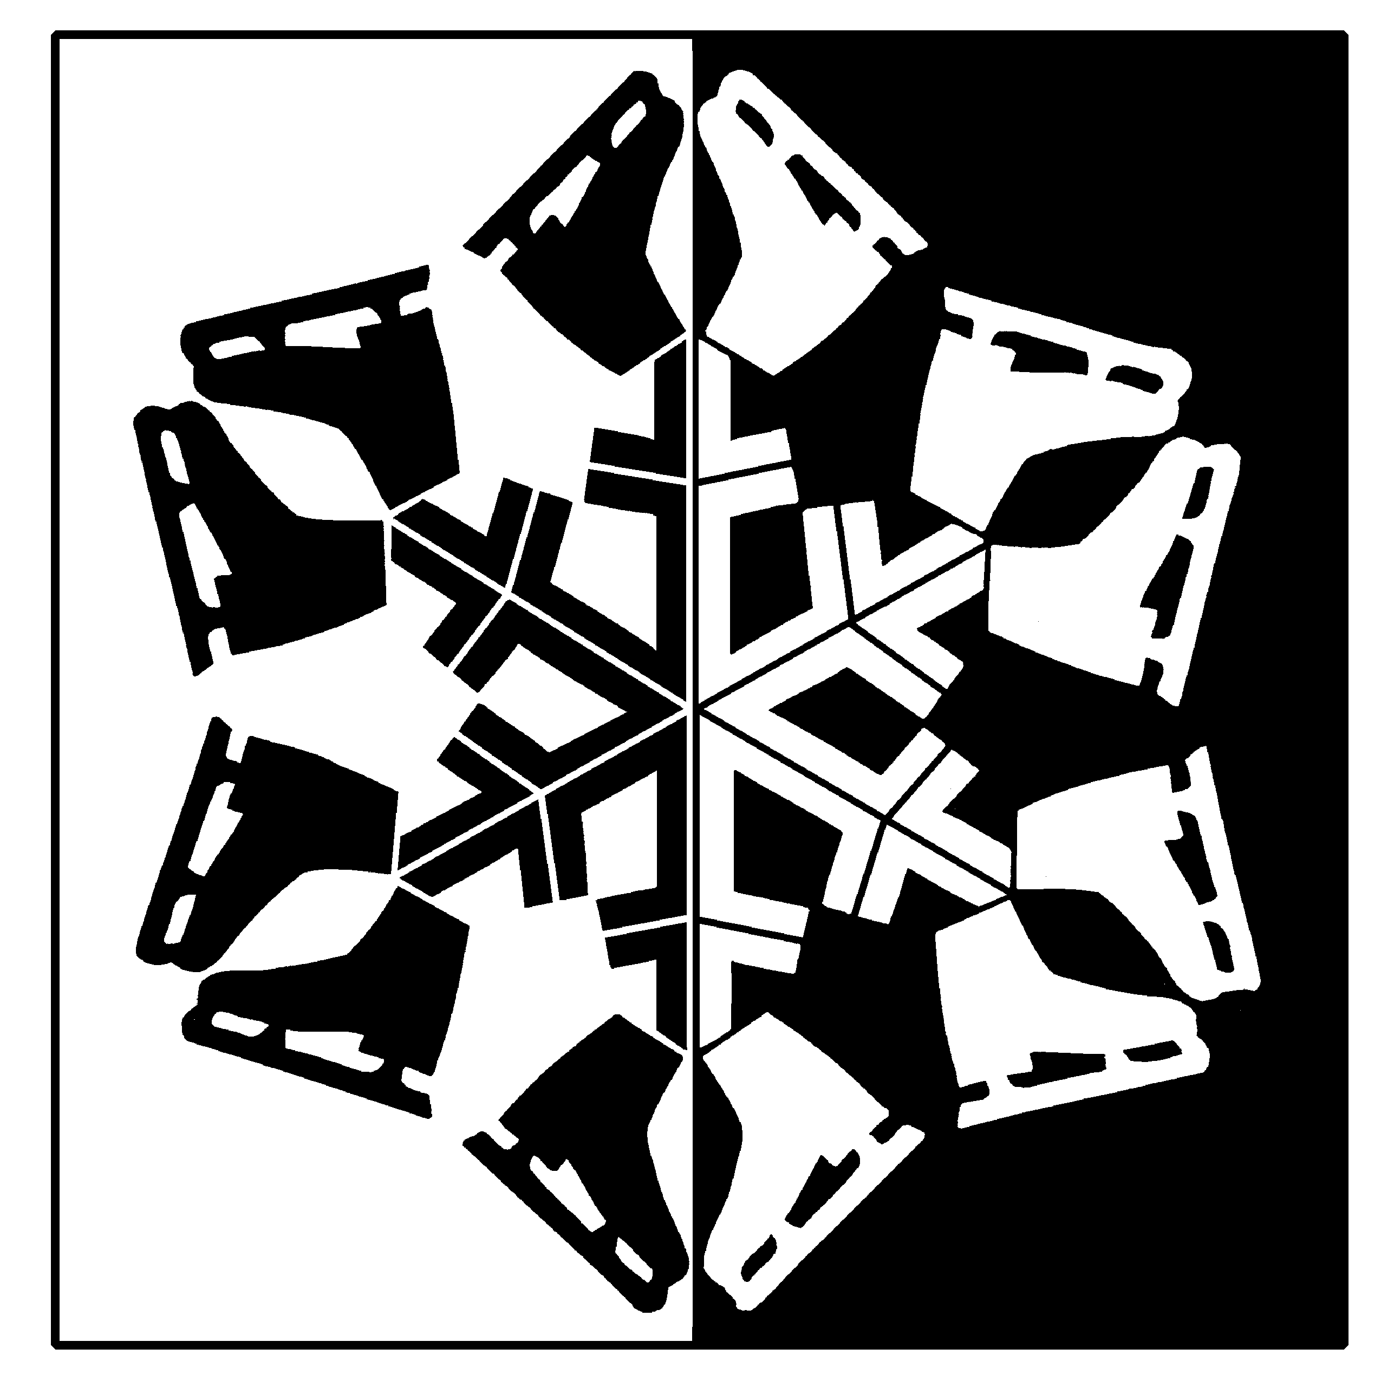

Hosted by:
The Figure Skating Club of the Quad Cities
The River’s Edge
700 W. River Drive
Davenport, IA 52802
(563) 322-5220

Web site: www.fscqc.org
Online Entry at www.entryeeze.com
For more information, please contact:
Jen Struss E-mail: jenstruss@msn.com
Susan Schwaegler E-mail: SDSCHWAEG@aol.com

Entry deadline – May 1, 2018

Referee: Sandy Bowen Accountant: Sandi Phelan

ELIGIBILITY RULES FOR PARTICIPANTS

The competition is open to ALL skaters who are current eligible (ER 1.00) members of either the Learn To Skate USA and/or are full members of U.S. Figure Skating. To be eligible, skaters must have submitted a membership application or be a member in good standing.
Eligibility will be based on skill level as of closing date of entries. All Snowplow Sam and Basic Skills skaters through Basic 6 must skate at highest level passed or one higher and NO official U.S. Figure Skating tests may have been passed including dance tests. Skaters in other events may skate at highest level passed OR one level higher BUT not both levels in the same event during the same competition.

SERIES INFORMATION - This competition is part of the Illinois Basic Skills Series.
2017-2018 Illinois Basic Skills Series

ENTRIES AND FEES
Registration on www.entryeeze.com
The following information will be needed to register:
Skater’s Name Address Date of Birth USFSA # or Basic skills # Email address Home Club/Learn to Skate USA program Coach’s Name Highest test levels
***Please provide an email address that is checked daily/regularly since this will be the method used for all contact.
The first event is $50.00 Additional events are $25.00 each

Entry deadline – May 1, 2018 Late fee is $35.00. No entries after this date without Competition Committee approval. Any changes after the close date will have a $35 fee per change.

REFUND POLICY - Entry fees will not be refunded after entry deadline unless no competition exists or the event is canceled. There will be no refunds for medical withdrawals. The online processing fees are not refundable. Contested credit card charges or returned checks will be issued a $30 fee. Payment of the fee will be required before the skater is allowed to participate in practice ice or events. Notification of competition and practice ice times will be available on www.entryeeze.com.

AWARDS – Everyone will receive an award. All events will be final rounds. Medals will be awarded to first, second, and third places. ALL other places will receive ribbons. ALL awards will be made at appropriate times throughout the competition.

SCHEDULE OF EVENTS - Will be posted on www.entryeeze.com approximately 2 weeks before the competition.

PRACTICE ICE – Practice ice will be reserved on www.entryeeze.com. Additional practice ice may be available at the Registration Desk during the competition

MUSIC - The music for all free skating programs and showcase must be provided on CD’s by the skater. CD’s should be clearly marked with the name of the skater, event entered and length of music (not skating time). Competition music is to be turned in at the time of registration. Time duration is always +/- 10 seconds.

VIDEO TAPING AND PHOTOGRAPHS - Videotaping and photography services will be provided if number of entrants is sufficient. No flash photography is permitted in the ice arena. The use of ice arena power sources is prohibited.

HOTEL ACCOMMODATIONS - We are holding standard rooms at the Radisson Quad City Plaza for Friday June 8 and Saturday June 9 at a rate of $111.00/night. You may make your reservations by calling 1-800-333-3333, mentioning the dates of your stay AND Figure Skating Club of the Quad Cities. Please make your reservations early, reservations made after May 8 will be at the regular rate.

EVENTS: The Quad Cities Championship will be using the standard 2017-2018 USFSA Non-Qualifying event elements which are found at http://www.usfsa.org/events?id=84207 for the following singles events:
- Basic Programs for levels Snowplow Sam – Basic 6
- Free Skate Programs for levels Pre-Free Skate and Free Skate 1-6
- Basic Elements for levels Snowplow Sam – Basic 6
- Compulsory Moves for levels Pre-Free Skate and Free Skate 1-6

U.S. Figure Skating Nonqualifying Competitions

EVENT: Basic Program Event: SNOWPLOW SAM – BASIC 6
Format: The skating order of the required elements is optional. The elements are not restricted as to the number of times the element is executed or length of glides, number of revolutions, etc., unless otherwise specified.
- To be skated on full ice.
- The skater may use elements from a previous level.
- A 0.2 deduction will be taken for each element performed from a higher level.

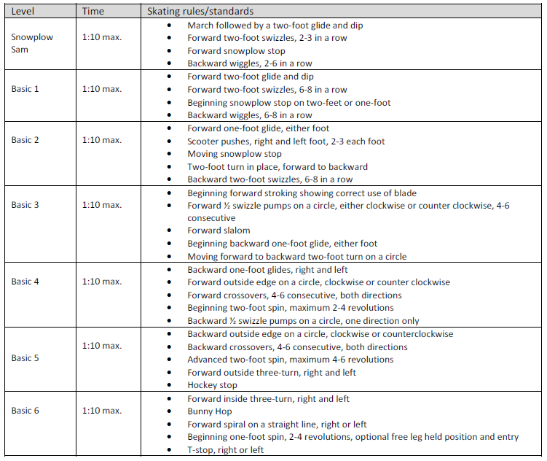

U.S. Figure Skating Nonqualifying Competitions

EVENT: Pre-Free Skate – Free Skate 6 Program Event

Format: The skating order of the required elements is optional. The elements are not restricted as to the number of times an element is executed, length of glides, number of revolutions, etc., unless otherwise stated. Connecting steps and transitions should be demonstrated throughout the program.
- To be skated on full ice.
- The skater must demonstrate the required elements and may use but is not required to use any additional elements from previous levels.
- A 0.2 deduction will be taken for each element performed from a higher level.
- Time 1:40 max.

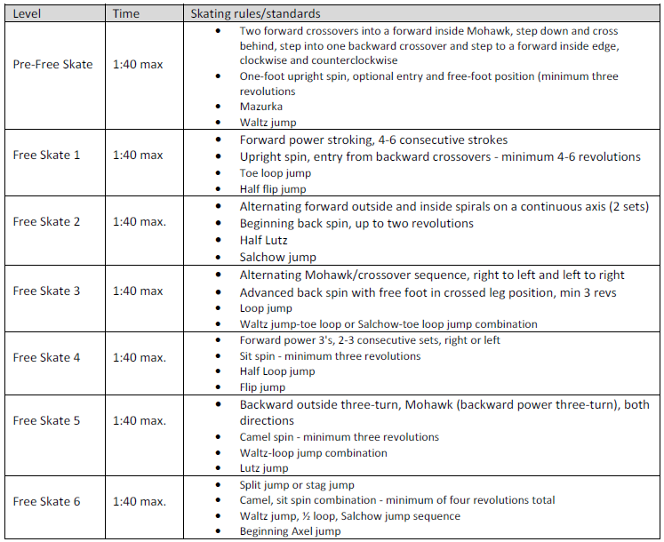

U.S. Figure Skating Nonqualifying Competitions

EVENT: Basic Elements Event: SNOWPLOW SAM – BASIC 6
Format choice of the host: Each skater will perform each element when directed by a judge or referee or have the option to perform one element at a time in the order listed below (no excessive connecting steps). Referee driven format examples: all skaters perform first element before moving on to the next and so on, or each skater performs all of the required elements before moving on to the next skater.
- To be skated on 1/3 to 1/2 ice.
- No music.
- All elements must be skated in the order listed.

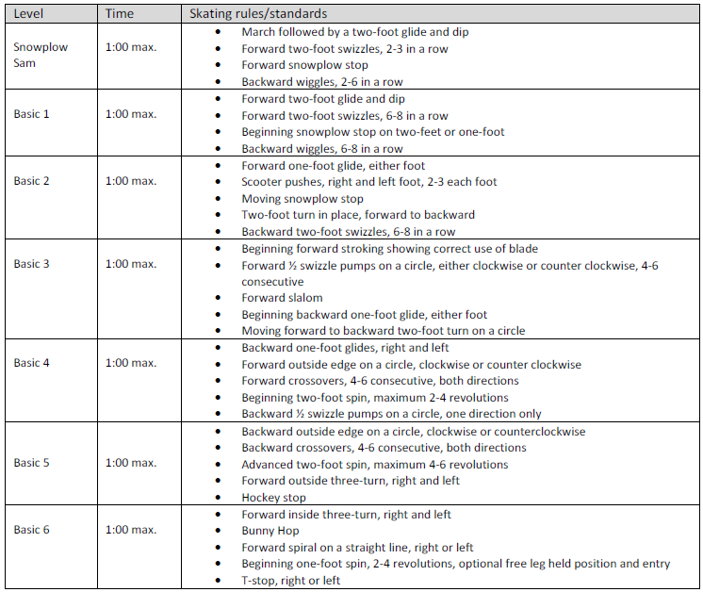

U.S. Figure Skating Nonqualifying Competitions

EVENT: Pre-Free Skate – Free Skate 6 Compulsory Event

Format: In simple program form, using a limited number of connecting steps, the skating order of the required elements is optional.
- To be skated on ½ ice.
- No music is allowed.
- The skater must demonstrate the required elements and may use any additional elements from previous levels.
- A 0.2 deduction will be taken for each element performed from a higher level.
- Time: 1:15 max

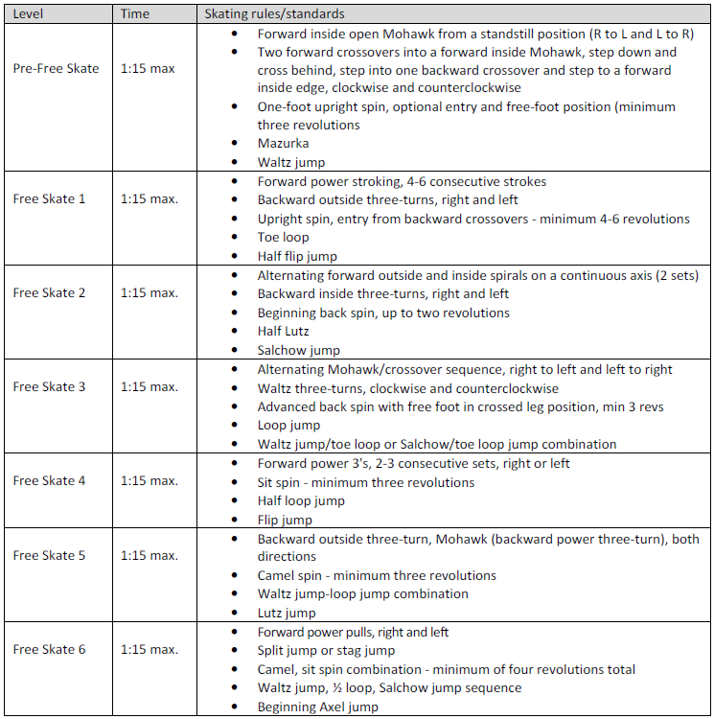

FUN/BONUS EVENTS: The events below do NOT follow the USFSA guidelines.

Artistic
Music may be vocal. Skater must interpret theme and temperament. Judging will emphasize interpretation and originality. Costumes are encouraged to enhance mood of music. Props allowed. Event will be divided by age where appropriate. Levels will be combined if entries warrant.
Duration is shown as a range, to accommodate those skaters with music for National Showcase.

LEVEL | ELEMENTS | QUALIFICATIONS | PROGRAM LENGTH
Basic 1-6 | Elements only from Basic 1-6 curriculum | May not have passed any higher than Basic 6 level. | Time 1:00 Max
Free skate Pre-6 | 3 jump maximum. ½ rotation jumps only, plus the following full rotation jumps: Salchow and toe loop. | May not have passed any official U.S. Figure Skating free skate tests. | Time: 1:30 Max

INTERPRETIVE
Competition Format:
The Organizing Committee will pre-select and edit musical choices appropriate for these events. During warm-up, skaters will hear selection of music twice. Following the warm-up, all skaters except for the first skater will be escorted to a soundproof locker room or another area of the arena. The first skater will hear the music one more time, and then perform a program to the music. As each skater performs, the next skater in line will be allowed to hear the music for the third time before they perform to the music. The listening skater will not be allowed to view the performing skater.

Coaching: There is to be no instruction allowed during this event from coaches, parents, or fellow skaters. Staging area must be kept clear except for ice monitor and listening competition.

Music Duration: Basic Skills and Free Skate 1-6: 1 minute max.

Theme: The music theme will be GLEE.

