Quad Cities Basic Skills Competition
June 12-14, 2015

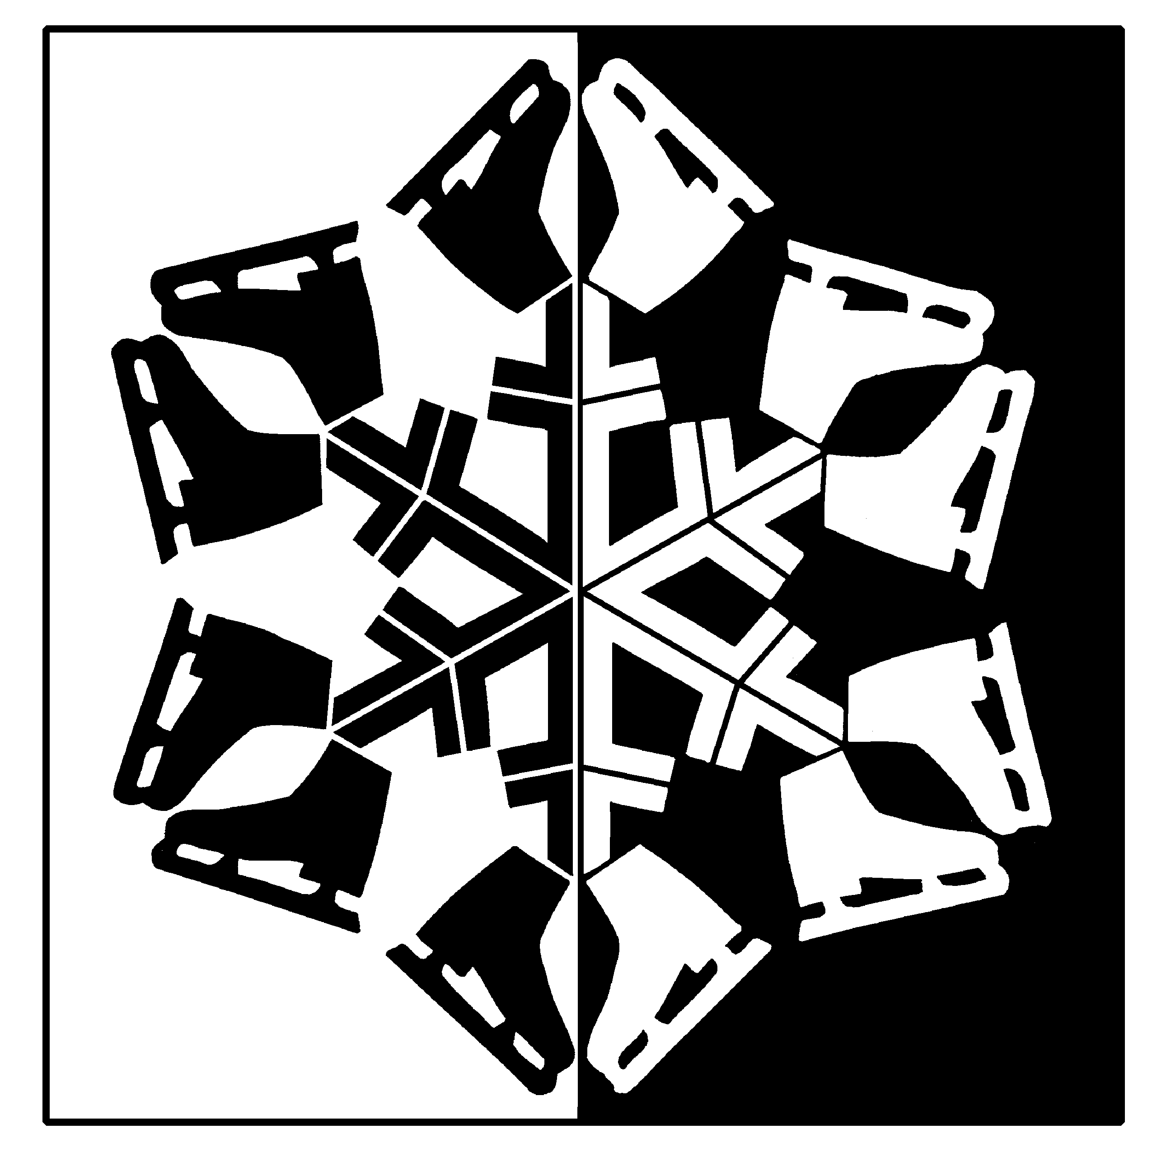

Hosted by:
The Figure Skating Club of the Quad Cities
The River’s Edge
700 W. River Drive
Davenport, IA 52802
(563)322-5220

Web site: www.fscqc.org
Online Entry at www.entryeeze.com
For more information, please contact:
Susan Collins E-mail: Sscollins3@aol.com
Susan Schwaegler E-mail: SDSCHWAEG@aol.com

Entry deadline – May 3, 2015

Referee: Sandy Bowen Accountant: Ed Mann

ELIGIBILITY RULES FOR PARTICIPANTS

The competition is open to ALL skaters who are current eligible (ER 1.00) members of either the Basic Skills Program and/or are full members of U.S. Figure Skating. To be eligible, skaters must have submitted a membership application or be a member in good standing. Members of other organizations are eligible to compete but must be registered with the host Basic Skills Program/Club or any other Basic Skills Program/Club.
Eligibility will be based on skill level as of closing date of entries. All Snowplow Sam and Basic Skills skaters through Basic 8 must skate at highest level passed or one higher and NO official U.S. Figure Skating tests may have been passed including dance tests. Skaters in other events may skate at highest level passed OR one level higher BUT not both levels in the same event during the same competition.

SERIES INFORMATION - This competition is part of the Illinois Basic Skills Series.

ENTRIES AND FEES
Registration on www.entryeeze.com
The following information will be needed to register:
Skater’s Name Address Date of Birth USFSA # or Basic skills # Email address Home Club/BS program Coach’s Name Highest test levels
***Please provide an email address that is checked daily/regularly since this will be the method used for all contact.
The first event is $50.00 Additional events are $25.00 each
Entry deadline – May 3, 2015 Late fee is $35.00
Each skater will receive a DVD of her/his Freeskate or Basic program that is included in the entry fee.

No entries after this date without Competition Committee approval. Any changes after the close date will have a $35 fee per change.

REFUND POLICY - Entry fees will not be refunded after entry deadline unless no competition exists or the event is canceled. There will be no refunds for medical withdrawals. The online processing fees are not refundable. Contested credit card charges or returned checks will be issued a $ 30 fee. Payment of the fee will be required before the skater is allowed to participate in practice ice or events. Notification of competition and practice ice times will be available on www.entryeeze.com.

AWARDS – Everyone will receive an award. All events will be final rounds. Medals will be awarded to first, second, and third places. ALL other places will receive ribbons. ALL awards will be made at appropriate times throughout the competition.

SCHEDULE OF EVENTS - Will be posted on www.entryeeze.com approximately 2 weeks before the competition.

PRACTICE ICE – Practice ice will be reserved on www.entryeeze.com. Additional practice ice may be available at the Registration Desk during the competition

MUSIC - The music for all free skating programs and showcase must be provided on CD’s by the skater. CD’s should be clearly marked with the name of the skater, event entered and length of music (not skating time). Competition music is to be turned in at the time of registration. Time duration is always +/- 10 seconds.

VIDEO TAPING AND PHOTOGRAPHS - Videotaping and photography services will be provided if number of entrants is sufficient. No flash photography is permitted in the ice arena. The use of ice arena power sources is prohibited.

HOTEL ACCOMMODATIONS - We are holding standard rooms at the Radisson Quad City Plaza for Friday and Saturday June 12 & 13 at a $104.00 rate. You may make your reservations by calling 1-800-333-3333, mentioning the dates of your stay AND Figure Skating Club of the Quad Cities or by logging onto www.radisson/fsqc2014.
Please make your reservations early, reservations made after May 5 will be at the regular rate.

EVENT: Basic Elements Event: SNOWPLOW SAM – BASIC 8
Format choice of the host: Each skater will perform each element when directed by a judge or referee or have the option to perform one element at a time in the order listed below (no excessive connecting steps). Referee driven format examples: all skaters perform first element before moving on to the next and so on, or each skater performs all of the required elements before moving on to the next skater.
- To be skated on 1/3 to 1/2 ice
- No music
- All elements must be skated in the order listed
Level | Time | Skating rules/standards
Snowplow Sam 1-3 | 1:00 max. | - March followed by a two-foot glide and dip  - Forward two-foot swizzles, 2-3 in a row  - Forward snowplow stop  - Backward wiggles, 2-6 in a row
Basic 1 | 1:00 max. | - Forward two-foot glide and dip  - Forward two-foot swizzles, 6-8 in a row  - Forward snowplow stop  - Backward wiggles, 6-8 in a row
Basic 2 | 1:00 max. | - Forward one-foot glide, either foot  - Forward alternating ½ swizzle pumps in a straight line, 2-3 each foot  - Moving snowplow stop  - Two-foot turn in place, forward to backward  - Backward two-foot swizzles, 6 - 8 in a row
Basic 3 | 1:00 max. | - Forward stroking  - Forward ½ swizzle pumps on a circle, either clockwise or counter clockwise, 4-6 consecutive  - Forward slalom  - Backward one-foot glide, either foot  - Two-foot spin – minimum three revolutions
Basic 4 | 1:00 max. | - Standstill forward outside three-turn, right and left  - Forward outside edge on a circle, clockwise or counter clockwise  - Forward crossovers, 4-6 consecutive, both directions  - Backward stroking, 4-6 strokes  - Backward snowplow stop, right or left
Basic 5 | 1:00 max. | - Backward outside edge on a circle, clockwise or counterclockwise  - Backward crossovers, 4-6 consecutive, both directions  - Basic one-foot spin, free leg held to side of spinning leg - minimum three revolutions  - Side toe hop, either direction  - Hockey stop
Basic 6 | 1:00 max. | - Standstill forward inside three-turn, right and left  - Bunny Hop  - Forward spiral on a straight line, right or left  - Lunge, right or left  - T-stop, right or left
Basic 7 | 1:00 max. | - Standstill forward inside open mohawk, right to left and left to right  - Ballet jump, either direction  - Back crossovers to a back outside edge landing position, clockwise and counter clockwise  - Forward inside pivot
Basic 8 | 1:00 max. | - Moving forward outside or forward inside three-turns, right and left  - Waltz jump (from a standstill)  - Mazurka, either direction  4. 1 Combination move, clockwise or counter clockwise, two forward crossovers into forward inside mohawk, step down, cross behind, step into one back crossover and step to a forward inside edge  5. Beginning one-foot upright spin, free foot held to side of spinning leg or crossed position - minimum three revolutions
EVENT: BASIC PROGRAM EVENT: SNOWPLOW SAM – BASIC 8
Format: The skating order of the required elements is optional. The elements are not restricted as to the number of times the element is executed or length of glides, number of revolutions, etc., unless otherwise specified. Vocal music is allowed.
- To be skated on full ice
- The skater may use elements from a previous level
- A 0.2 deduction will be taken for each element performed from a higher level

Level | Time | Skating rules/standards
Snowplow Sam 1-3 | 1:00 +/-10 max. | - March followed by a two-foot glide and dip  - Forward two-foot swizzles, 2-3 in a row  - Forward snowplow stop  - Backward wiggles, 2-6 in a row
Basic 1 | 1:00 +/-10 max. | - Forward two-foot glide and dip  - Forward two-foot swizzles, 6-8 in a row  - Forward snowplow stop  - Backward wiggles, 6-8 in a row
Basic 2 | 1:00 +/-10 max. | - Forward one-foot glide, either foot  - Forward alternating ½ swizzle pumps in a straight line, 2-3 each foot  - Moving snowplow stop  - Two-foot turn in place, forward to backward  - Backward two-foot swizzles, 6 - 8 in a row
Basic 3 | 1:00 +/-10 max. | - Forward stroking  - Forward ½ swizzle pumps on a circle, either clockwise or counter clockwise, 4-6 consecutive  - Forward slalom  - Backward one-foot glide, either foot  - Two-foot spin, minimum three revolutions
Basic 4 | 1:00 +/-10 max. | - Standstill forward outside three-turn, right and left  - Forward crossovers, 4-6 consecutive both directions  - Backward stroking, 4-6 strokes  - Backward snowplow stop, right or left
Basic 5 | 1:00 +/-10 max. | - Backward crossovers, 4-6 consecutive, both directions  - Basic one-foot spin, free leg held to side of spinning leg, minimum three revolutions  - Side toe hop, either direction  - Hockey stop
Basic 6 | 1:00 +/-10 max. | - Standstill forward inside three-turn, right and left  - Bunny Hop  - Forward spiral on a straight line, right or left  - Lunge, right or left  - T-stop, right or left
Basic 7 | 1:00 +/-10 max. | - Standstill forward inside open Mohawk, right to left and left to right  - Ballet Jump, either direction  - Back crossovers to a back outside edge landing position, clockwise and counter clockwise  - Forward inside pivot
Basic 8 | 1:00 +/-10 max. | - Moving forward outside or forward inside three-turns, right and left  - Waltz jump (from at standstill)  - Mazurka, either direction  4. 1 Combination move, clockwise or counter clockwise – two forward crossovers into a forward inside Mohawk, step down, cross behind, step into one back crossover and step to a forward inside edge  5. Beginning one-foot upright spin, free foot held to side of spinning leg or crossed position -minimum three revolutions

EVENT: Free Skate 1-6 Compulsory Event

Format: In simple program form, using a limited number of connecting steps, the skating order of the required elements is optional
- To be skated on ½ ice
- No music is allowed
- The skater must demonstrate the required elements and may use any additional elements from previous levels
- A .2 deduction will be taken for each element performed from a higher level
- Time: 1:15 or less

Level | Time | Skating rules / standards
Free Skate 1 | 1:15 max. | - Advanced forward stroking, 4-6 consecutive  - Backward outside three-turns, right and left  - One-foot upright scratch spin from backward crossovers - minimum three revolutions  - Waltz jump from backward crossovers  5. Half flip jump
Free Skate 2 | 1:15 max. | - Forward outside or inside spiral, right or left  - Waltz three's, right or left, 2-3 sets  - Beginning back spin, entry optional – minimum two revolutions  - Waltz jump, side toe hop, waltz jump sequence  - Toe loop jump
Free Skate 3 | 1:15 max. | - Forward crossovers in a figure 8  - Backward inside three-turns, right and left  - Back spin - minimum three revolutions  - Salchow jump  - Waltz jump/toe loop or Salchow/toe loop jump combination
Free Skate 4 | 1:15 max. | - Forward power 3's, 2-3 consecutive sets, right or left  - Sit spin - minimum three revolutions  - Loop jump  - Waltz jump/loop jump combination
Free Skate 5 | 1:15 max. | - Camel spin - minimum three revolutions  - Forward upright spin to back upright spin - minimum three revolutions each foot  - Loop/loop jump combination  - Flip jump
Free Skate 6 | 1:15 max. | - Five step mohawk sequence - one set alternating pattern (refer to Basic Skills Curriculum Free skate 6)  - Camel, sit spin combination - minimum of four revolutions total  - Split jump or stag jump  - Waltz jump, ½ loop, Salchow jump sequence  - Lutz jump

EVENT: Free Skate 1-6 Program Event

Format: The skating order of the required elements is optional. The elements are not restricted as to the number of times an element is executed, length of glides, number of revolutions, etc., unless otherwise stated. Connecting moves and steps should be demonstrated throughout the program. Vocal music is allowed.
- To be skated on full ice
- The skater must demonstrate the required elements and may use but is not required to use any additional elements from previous levels
- A 0.2 deduction will be taken for each element performed from a higher level
- Time 1:30+/-10sec

Level | Time | Skating rules / standards
Free Skate 1 | 1:30+/-10 sec | - Advanced forward stroking, 4-6 consecutive  - One-foot upright scratch spin from backward crossovers, minimum three revolutions  - Waltz jump from backward crossovers  4. Half flip jump
Free Skate 2 | 1:30+/-10 sec | - Forward outside spiral, right or left  - Beginning back spin – entry optional, minimum two revolutions  - Waltz jump, side toe hop, waltz jump sequence  - Toe loop jump
Free Skate 3 | 1:30+/-10 sec | - Forward crossovers in a figure 8  - Back spin, minimum three revolutions  - Salchow jump  - Waltz jump-toe loop or Salchow-toe loop jump combination
Free Skate 4 | 1:30+/-10 sec | - Forward power 3's, 2-3 consecutive sets, right or left  - Sit spin, minimum three revolutions  - Loop jump  - Waltz jump-loop jump combination
Free Skate 5 | 1:30+/-10 sec | - Camel spin, minimum three revolutions  - Forward upright spin to back upright spin, minimum three revolutions each foot  - Loop-loop jump combination  - Flip jump
Free Skate 6 | 1:30+/-10 sec | - Camel, sit spin combination, minimum of four revolutions total  - Split jump or stag jump  - Waltz jump, ½ loop, Salchow jump sequence  - Lutz jump

FUN/BONUS EVENTS: These events do NOT follow the USFSA guidelines.

Artistic
Music may be vocal. Skater must interpret theme and temperament. Judging will emphasize interpretation and originality. Costumes are encouraged to enhance mood of music. Props allowed. Event will be divided by age where appropriate. Levels will be combined if entries warrant.
Duration is shown as a range, to accommodate those skaters with music for National Showcase.

LEVEL | ELEMENTS | QUALIFICATIONS | PROGRAM LENGTH
Basic 1-8 | Elements only from Basic 1-8 curriculum | May not have passed any higher than Basic 8 level. | Time 1:00 Max
Free skate 1-6 | 3 jump maximum. ½ rotation jumps only, plus the following full rotation jumps: Salchow and toe loop. | May not have passed any official U.S. Figure Skating free skate tests. | Time: 1:30 Max

INTERPRETIVE
Competition Format:
The Organizing Committee will pre-select and edit musical choices appropriate for these events. During warm-up, skaters will hear selection of music twice. Following the warm-up, all skaters except for the first skater will be escorted to a soundproof locker room or another area of the arena. The first skater will hear the music one more time, and then perform a program to the music. As each skater performs, the next skater in line will be allowed to hear the music for the third time before they perform to the music. The listening skater will not be allowed to view the performing skater.

Coaching: There is to be no instruction allowed during this event from coaches, parents, or fellow skaters. Staging area must be kept clear except for ice monitor and listening competition.

Music Duration: Basic Skills and Free Skate 1-6: 1 minute max.

Theme: The music theme will be “Show Tunes”.

